John Kowalski¹, Jane Smithson²
¹University of ZZZZ, Faculty or Department XXXX, city, country, ²University of QQQQ, Faculty or Department YYYY, city, country
TITLE of EXTENDED Abstract (IN ENGLISH)
Keywords: up to 6 keywords in English, we suggest to use the list published in: https://www.ieee.org/content/dam/ieee-org/ieee/web/org/pubs/ieee-taxonomy.pdf

Introduction
The paper should be prepared using A4 paper format, margins: all – 2.0 cm, page header 1.5 cm, footer 1.5 cm – different odd and even, different first page; two columns – width 8.2 cm, spacing 0.6 cm, no line between. Authors are requested to use predefined styles only as they are listed in Table 1.
The text after the chapter title begins with 5 mm indent. The main text of the paper should be written in Times New Roman 9 points, single spacing, without automatic hyphenation.
- Chapter title
Abstract should not be longer than 2 pages and contain brief presentation of the work, original achievements and a summary. The author should make efforts to fill a total volume of pages with formatted article. We propose to write the text directly on this template, it will help you to meet the editorial requirements. Please do not break the text – do not use non-breaking spaces, hard (manual) line breaks, etc. The Editor reserves the right to editorial redaction of the submitted texts.
- Equations
Equations should be written in Microsoft Equation 3.0 (preferred one) or built-in MS Word equation editor. The symbols used in equations should be of size corresponding to that of the paragraph font, assuming 9 points as a basic size and subscripts/superscripts proportionally smaller. Variables should be written using italic but constants and numbers in normal typefaces.
Equations should be numbered consecutively in the whole text of the paper. The numbers of equations should be aligned right. Do not insert blank lines between the equation and text. Equations should be treated as a part of the sentence, i.e.:
(1)
where k is the static gain, denotes the natural pulsation in rad/s and ζ the damping factor.
- Figures and tables
Figures and tables together with captions should appear as close as possible to the places in which they are referred to for the first time. The figures should be numbered consecutively in the whole text of the paper and captioned in the language of the paper. Adequate styles should be used. Do not use automatic numbering!
It is allowed to insert good quality photographs. If colour option is not requested only the greyscale photos should be inserted. Preferably, the drawing should have a width of 8.5 cm or 17 cm. Descriptions of the drawings should be legible and their size must be no less than of the caption below the figure.
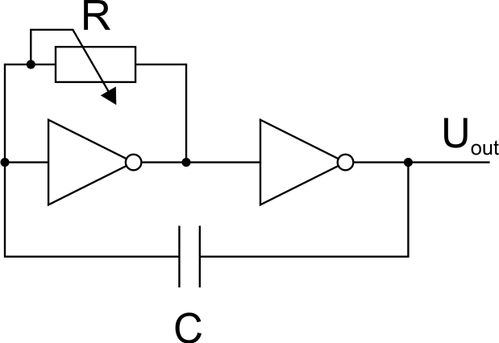
Fig. 1. Circuit layout
It is not allowed to use built-in Microsoft Office shapes to construct a figure or use text fields to describe it. Do not insert blank lines between the figure and text.
Table 1. Main styles predefined in abstract template
field | style
author(s) | 01_autors
affiliation | 02_affiliation
title of extended abstract (in English) | 03_paper_title
keywords | 04_keywords
introduction | 05_introduction
body text | 06_BODY_TEXT
chapter title | 07_chapter_title
subsection title | 08_chapter_title_2
equation | 12_equation
figure | 13_figure
figure caption | 14_figure_caption
table | 15_table
table caption | 16_table_caption
references – header | 17_references_title
references – entry | 18_reference_entry
For internal use only | _Naglowek_strony
For internal use only | _stopka

Tables should be numbered and captioned above the table, as in the example above. Please insert one line spacing after the table. Do not use automatic numbering of tables.
- Bulleted and numbered lists
Predefined styles should also be used for bulleted and numbered lists, as in the examples:
- bulleted list – justified, no indent, text separated from the tabulation symbol 0.5 cm, the next line indented 0.5 cm,
- numbered list – justified, no indent, round parenthesis style, text separated from the tabulation symbol 0.5 cm, the next line indented 0.5 cm.
- Reference linking
Denote reference citations within the text by number in square brackets. List references at the end of the paper in alphabetical order by author's last name and enclose the reference number in square brackets. Do not use automatic referencing. Other references, such as web addresses, norms, titles, records, etc. should be placed at the end of the list.
References
- Kluszczyński K., Spałek D.: Computer program for step-by-step analysis of asynchronous machine. Proceedings of XXVI Seminar on Fundamentals of Electrotechnics and Circuit Theory IC-SPETO, Gliwice-Niedzica 2003. Vol. II, 505–508.
- Omiotek Z., Wójcik W.: The use of Hellwig’s method for dimension reduction in feature space of thyroid ultrasound images. Informatyka, Automatyka, Pomiary w Gospodarce i Ochronie Środowiska – IAPGOS 3/2014, 14–17 [http://doi.org/10.5604/20830157.1121333].
- Sankowski D., Mosorow W., Strzecha K.: Przetwarzanie i analiza obrazów w systemach przemysłowych. PWN, Warszawa 2011.
- gcep.stanford.edu/pdfs/QeJ5maLQQrugiSYMF3ATDA (available: 10.05.2016).

